Iona School for ministry
Apparel Order Form

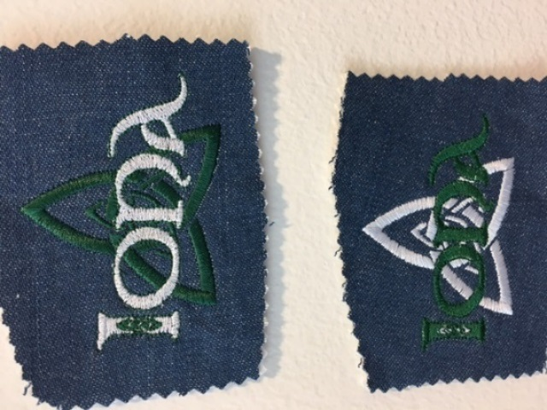
Embroidery Samples

This form can be completed electronically or manually. An electronic version must be requested.

Iona School for Ministry

Apparel Ordering Information & Procedure
2020-2021

The purchase of embroidered apparel is strictly optional. This is not a uniform.
BlueGeneration is the sole provider for Iona School apparel.

Order Deadline
The deadline for submitting this order is Friday, November 6, 2020.

Procedure
1. Determine the kind of apparel you wish to order. Style choices are limited to those noted under “Approved Apparel” on the next page.
2. Order forms are submitted to Laura McAlister and can be delivered several ways.
Complete electronically and return to Laura via email
Give to a Dean at an Iona School session
Email as a pdf attachment to lmcalister@epicenter.org
US Post to: Laura McAlister
Iona School for Ministry
510 Rathervue Pl.
Austin, TX 78705

3. Depending on delivery date the apparel will either be distributed at the next Iona School session or will be mailed directly to you.

Cost & Payment
Apparel is priced to break even and to cover the cost of the apparel item, custom embroidery, and shipping. No profit is made from these sales. Payment may be made
by check or credit card and must accompany order. Checks are made payable to Episcopal Diocese of Texas (EDOT). Notate “Iona apparel’ on the memo line. For credit card payments the information requested at the bottom of the order form must be provided.

Refund/Return Policy
Only apparel with a manufacturer defect/error will be eligible for refund, return or exchange, OR if a mistake is made in the placing of the order to the vendor. Make
sure the size, color and style you put on the form is exactly what you want. There
are no refunds, returns or exchanges for order forms completed inaccurately.

Please direct any questions to Laura, 512-478-0580.

Approved Apparel
Pictures and color samples are found at the BlueGeneration website: https://www.bluegeneration.com/
Go to the BlueGeneration website for color selections. Write the color name that is used on the website under the ‘color’ column on
the order form. Also, larger, and tall sizes are available on some styles. For pricing on these items, and if there is something that you would like to order from BlueGeneration that is not on the list, call Laura to discuss, 512-478-0580.

Style Category | Style Type | Style Number | Size Range | Pricing | Description
Knit Shirts Cotton Piques | Men’s Polo | 2201 | xs-3XL | $25.00 | 100% Egyptian ring spun cotton, stain release, tailored classic fit, 6.7 ounce, 3 button plackets, bone horn buttons. Men’s: Tail back, side vents
 |  |  | 4XL-6XL | $30.00
 | Ladies’ Polo | 6201 | s-3XL | $25.00 | Women’s: Straight bottom
 |  |  | 4XL | $30.00
Woven Shirts Denim | Men’s long sleeved | 8206 | xs-2XL | $25.00 | 100% cotton, 7 ounce, sand washed for extra softness and shrinkage control, button down collar, center pleated back, double back yoke, patch pocket, adjustable cuffs, button sleeve placket
 |  |  | 3XL-5XL | $30.00
 | Men’s short sleeved | 8206S | xs-3XL | $25.00
 |  |  | 4XL-5XL | $30.00
 | Women’s long sleeved | 8202 | s-2XL | $25.00
 |  |  | 3XL-4XL | $30.00
 | Women’s short sleeved | 8202S | s-2XL | $25.00
 |  |  | 3XL-4XL | $30.00

Continued on next page.

Approved Apparel (continued)

Style Category | Style Type | Style Number | Size Range | Pricing | Description
Woven Shirts Cotton Twill | Men’s long sleeved | 8213 | xs-4XL | $30.00 | 100% cotton. 6.5 ounce, colorfast twill, washed, preshrunk, button down collar, double back yoke, 2 side back pleats, Bone horn buttons, Classic Fit
 |  |  | 5XL-6XL | $40.00
 | Men’s short sleeved | 8213S | xs-4XL | $30.00 | Men’s: Patch pocket
 |  |  | 5XL-6XL | $40.00
 | Women’s long sleeved | 6213 | s-4XL | $30.00 | Women’s: Curved bottom
 | Women’s short sleeved | 6213S | s-4XL | $30.00
Outerwear Polar Fleece Jackets | Men’s Fleece Jacket | 9951 | s-XL | $32.00 | 100% polyester, Blue Generation's Polar Face 9.6 oz. anti-pill polar fleece, stitched shoulder yoke, 2 front zip pockets, taped collar, cuff & waistband with elastic, matching color front zipper, adjustable bungee drawstring.
 |  |  | 2XL-4XL | $43.00
 | Women’s Fleece Jacket | 6951 | s-XL | $33.00
 |  |  | XL2-4XL | $43.00
Outerwear Adult Fleece Hoodies | Men’s & Women’s Zippered | 9302Z | xs-2XL | $30.00 | 70/30 combed ring spun cotton/poly blend, 9 ounces, double fleece lined hood, striped ribbon neck tape, 1 X 1 rib cuffs and waistband w/spandex. Brass zip front.
 |  |  | 3XL-4XL | $40.00
 |  |  | 5XL-6XL | $47.00
 | Men’s & Women’s Pullover | 9301P | xs-3XL | $30.00 | Pullover: front pouch with double needle stitching, brass metal drawstring eyelets with heavy gauge drawstring.
 |  |  | 4XL-6XL | $43.00

Iona School for Ministry
Apparel Order Form

Completing and returning the form via email.
To complete this form electronically place cursor on or near the x or in the box in the grid below. Use the tab or arrow keys to move from box to box. Type in the information requested. To return the form once completed, save the form as a new document on your computer. It can be saved as either a Microsoft Word document or Adobe pdf. Return the new document via email as an attachment to ionaadmin@epicenter.org.

Name: | x

Daytime phone: | x | Email: | x

Referencing the information under Approved Apparel, provide all the information requested under each column. Color names are obtained from the website. Payment must accompany order.

Style Category | Style Type | Style Number | Size | Color | Price  (per unit) | Qty | Extended Total  ($Unit x Qty)
 |  |  |  |  | $ |  | $
 |  |  |  |  | $ |  | $
 |  |  |  |  | $ |  | $
DID YOU PROVIDE ALL THE INFORMATION NEEDED?
 | Total items ordered:
 | Total amount due: |  | $

Credit Card Payments
VISA, MasterCard and American Express are accepted for tuition and fees. Credit card payments are made online via PayPal via the Iona School website ionaschool.com. Follow the instructions below to make a credit card payment.
•Go to www.ionaschool.com
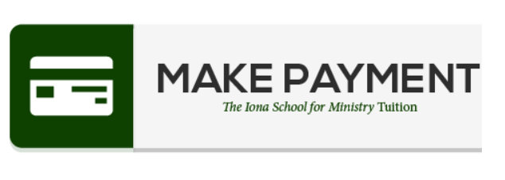
•Click on Admissions at the top of the page
•Scroll down to Tuition & Fees
•Scroll a little more until you see this icon
•Click on the icon.
•Enter the amount you wish to pay. Then click on this button.
•It will take you to a form. Provide all the information requested.
•Once you have completed from, click on the Donate Now button.

For office use only:
Check #_________ Date__________ Amount___________ CrCd___________

