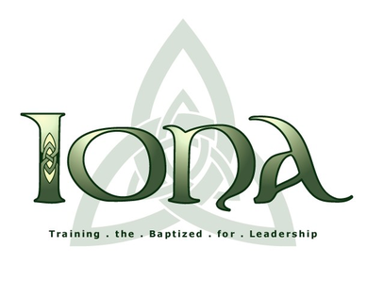

The Holy Eucharist

Rite II

April 14, 2024

The Third Sunday of Easter
Iona School for Ministry
Camp Allen, Navasota, Texas
Celebrant – The Rev. Jim Harrington
Deacon – The Rev. Vicki Knipp

The Word of God
Opening Hymn – Christ is Alive! Let Christians Sing Hymnal 1982, #182

Opening Acclamation BCP p. 355

The Gloria BCP p. 356

The Collect of the Day

The Lessons

The First Reading Acts 3:12-19

Psalm to be read antiphonally Psalm 4 BCP 587-588

The Second Reading 1 John 3:1-7

Sequence Hymn – Loves Redeeming Work is Done Hymnal 1982, #188

The Gospel Luke 24:36b-48

The Sermon Karen Pettit

The Nicene Creed BCP p. 358

The Prayers of the People Bulletin p. 3-4

Confession of Sin BCP p. 360

The Peace BCP p. 360

The Holy Communion
Offertory Hymn – On Christ the Solid Rock Lift Every Voice and Sing (LEVAS) p. 99

Eucharistic Prayer C BCP p. 370

The Lord’s Prayer BCP p. 364

The Breaking of the Bread BCP p. 364
Communion Hymn – One Bread, One Body LEVAS p. 151

Prayer after Communion BCP p. 365

The Blessing BCP p. 366

Closing Hymn – He Lives! LEVAS p. 42

Music: Michael Thompson, Kelly McCrae
Lectors: Suzanne Hollifield, Sheila Thrash, Ashley Harper-Oberle
Prayers of the People: Kelly Barnhill
Greeters: Warren Robinson, Kim Kibby

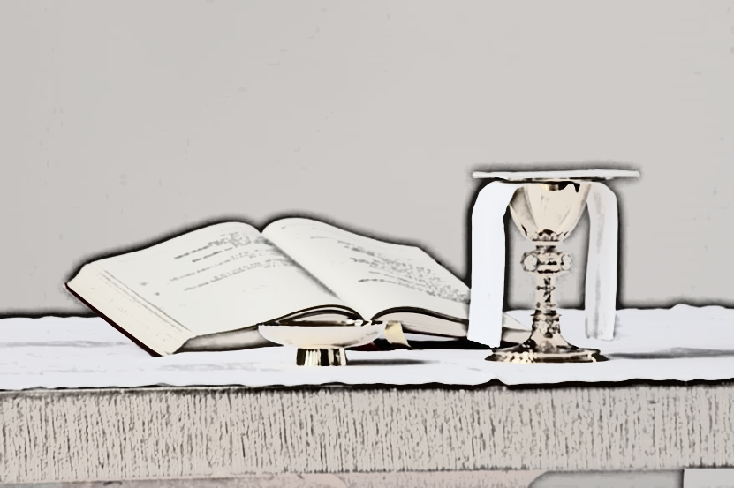

Prayers of the People

Good and gracious God, our most glorious Creator, as we greet all the signs in nature around us: of Spring once again in bloom, in the songs of returning birds, the abundance of wildflowers, and the gardens soon to be planted, we give you praise for an even greater sign of new life: the resurrection of your Son, Our Lord Jesus Christ, that we especially celebrate in this Eastertide.
silence
Creator of All that is, seen and unseen:

Your Son said, 'Peace be with you'. We pray you bring your peace to the world.

Lord, in your mercy: Hear our prayer.
We pray for your help, in guiding us to perceive the earth as the great mother she is. Help us to discover your exquisite presence in every living thing and the whole of creation. Teach us to honor Mother Nature as the parent she is.
Lord, in your mercy: Hear our prayer.

We pray you enable us to change our habits, in small ways and in big ways, so that life continues on earth in its abundance and variety. Transform our daily moments of awe into passionate care of the earth.
Lord, in your mercy: Hear our prayer.
We pray for our bishops, this diocese, the Anglican communion, our priests, this community, and also for all people who notice and tend to the needs of others. We pray for the church to be your daily presence in the world — healing, feeding, sheltering, and caring for one another, always.
Lord, in your mercy: Hear our prayer.

We pray you bless all who model and teach us faith: bishops and priests, and everyday saints we encounter day by day.
Lord, in your mercy: Hear our prayer.
We pray you move political leaders and nations into action that showers more and more people with health, economic security, and dignity. Move us away from the prejudices that keep us from knowing and understanding others. Heal all victims and liberate those wrongly imprisoned or detained.
Lord, in your mercy: Hear our prayer.

We pray for your healing of the world and its wounds of judgment, banishment, and exclusivity. Teach us to be like the good Samaritan and help us to discover our neighbor in every person we meet. Teach us to trade hatred for love, prejudice for empathy, self-interest for generosity.

Lord, in your mercy: Hear our prayer.

We pray for all people in their daily life and work, for our families, friends, and neighbors, for those who are alone, for all who suffer and all who mourn, those who journey from illness to health, from despair to hope, from grief to consolation, from loneliness to love.
Lord, in your mercy: Hear our prayer.

We pray for your presence and companionship in this unique community of Iona, allowing nurturing relationships to blossom here and radiate out from it. In the midst of our deep human connection, we see the face of God. Teach us to give and receive strength from sharing the best and worst life offers within this and other communities of caring. Move us beyond any fear that keeps us from loving.
Lord, in your mercy: Hear our prayer.

