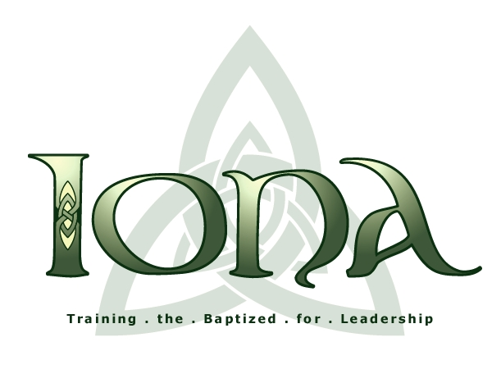The Iona School for Ministry

Old Testament
Former Prophets / Historical Books
First Year
November 5, 2022
The Rev. Michael Floyd

Study Guide

Chronology

1) Review the timeline previously handed out. Also consult the “Chronology of Significant Events,” Nelson, pp. 317-318, and also the “Timeline” in the Tables section toward the end of NOAB (pp. 2254-2257 in the edition that I have). Be able to list the following periods of biblical history in order, and to give their approximate duration (e.g., “from the tenth century to the early sixth century”).

a) Tribal league
b) Monarchy
c) Babylonian exile
d) Persian Period: Restoration
e) Greek period: Alexander the Great
f) Hellenistic Period 1: Ptolemaic rule
g) Hellenistic Period 2: Seleucid rule
h) Hasmonean rule
i) Roman Period

2) Within this chronological framework, be able to give the approximate dates of the following historical turning points:

- Occupation of Canaan and formation of the Israelite tribal league
- Transition to monarchy beginning with Saul and completed by David
- Dissolution of the Davidic United Kingdom caused by revolt of the northern tribes and formation of their own kingdom
- Fall of the northern kingdom of Israel to the Assyrians
- Fall of the southern kingdom of Judah to the Babylonians
- Babylonian exile
- Decree of the Persian emperor Cyrus authorizing the return of Judean exiles from Babylon to rebuild Jerusalem and its temple
h) Conquest of Alexander the Great and the beginning of Hellenistic cultural
influence
i) The Maccabean revolt against Seleucid rule
j) The beginning of Roman rule
k) The Jewish revolts against Roman rule

To answer the following questions, in addition to the assigned sections of Nelson, draw on the short reading entitled “Two Views of Isral’s National Past.”

The Deuteronomistic History (DtH)

1) What biblical books make up the document that scholars call the Deuteronomistic History (DtH)?

2) How is DtH related to the book of Deuteronomy (D)? What is the difference between the Deuteronomic perspective on the ideal of covenant fidelity and the Deuteronomistic perspective on that same ideal?

3) How does DtH structure (i.e., periodize) its narrative portrayal of the era of the tribal league? (Deut + Josh-Judg)?

4) How was the tribal league and its leadership organized, and how did it function socio-politically?

5) According to DtH, what developments precipitated the crisis that led to the demise of the tribal league?

6) How does DtH structure (i.e, periodize) its narrative portrayal of the era of the monarchy? (1 Sam-2 Kgs)?

7) How was the monarchy established by David organized and how was it socio-politically different from the tribal league and the kind of monarchy represented by Saul? (1 Sam 8:10-18;)

8) According to DtH, what was the sin that plagued the northern kingdom of Israel from its inception to its downfall? (1 Kgs 12:25-33) What was the cause of the fall of Israel to the Assyrians in the 8th century BCE? (2 Kgs 17:1-18?

9) According to DtH, who were the three kings of Judah that ruled well, what was the cause of the fall of Judah to the Babylonians in the 6th century BCE, and who was the villainous king who precipitated that fall? (2 Kgs 18:1-8; 23:25-27; 25:8-12)

10) What is the message implied in DtH’s portrayal of Israel’s history in terms of a covenant community that existed in two forms, each of which proved to be an adequate embodiment of the covenant relationship under particular historical conditions but finally proved to be an inadequate embodiment of that relationship in a crisis situation?

The Chronicler’s History (CH)

11) What biblical books make up the document that scholars call the Chronicler’s History?

12) How does CH present the pre-history of Israel prior to David?

13) How is CH’s description of the reigns of David and Solomon different from DtH’s description?

14) How does CH’s narrative describe the history of the Israelite monarchy post-David and Solomon, and how does this differ from DtH’s description?

15) What is the message implied in CH’s portrayal of Israel’s history primarily in terms of a covenant community gathered around a temple founded by a messianic king?

1 and 2 Maccabees

These two books are often neglected because they are in the Apocrypha. But they are “historical books” just as much as DtH and CH, and they are very important for understanding New Testament times. We should at least have a general idea of what they are about. There is no reading assigned from these books themselves, only the general description given in the textbook. We will add some details in class.

Womanist Midrash

We will cover the material in Wilda Gafney’s book, Womanist Midrash, by dividing up into two groups and having each group read a section of Part II in that book, as follows:

Group 1 pp. 131-201 Group 2, pp. 203-275
Kimberly Kibby Michael Thompson
Roger Olier Sheila Thrash
Warren Robinson

In the afternoon session each group will discuss and present their idea(s) of how Garney’s work contributes to our interpretation of the particular text we will be working on in the afternoon class, 1 Kings 17:8-24.

