Iona School for Ministry
Saturday, January 9, 2021 – Week of the Epiphany
Evening Prayer: Rite Two

The Invitatory and Psalter

Opening Sentence BCP 116
Invitatory BCP 117
O Gracious Light – Phos hilaron BCP 118

Psalm 131, 132 (responsively) BCP 785-787

The Lessons

The Lesson John 5:1-15

The Song of Mary – Magnificat BCP 119
Homily
The Apostles’ Creed BCP 120

The Prayers

The Lord’s Prayer BCP 121
Suffrage B BCP 122

The Collect of the Day BCP 214
A Collect for Saturdays BCP 123
A Collect for Peace BCP 123
A Prayer for Mission BCP 124

Hymn 125 “The People who in Darkness Walked’’ EH 125

Intercessions and Thanksgivings
A Prayer for Knowledge of God’s Creation BCP 827

Closing Sentence BCP 126

Officiant: Jack Karn
Lectors: Eric Ellis, Patti Peacock
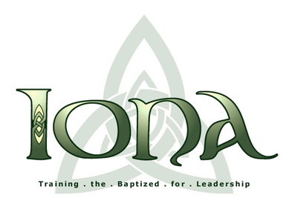
Respondent: Linda Ford

