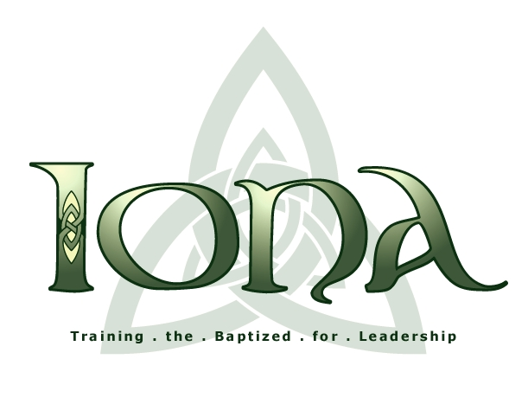The Iona School for Ministry

Old Testament
Latter Prophets
First Year
December 3, 2022
The Rev. Michael Floyd

Study Guide

The prophetic books are perhaps the type of biblical literature that is most difficult to get an introductory grasp on. Up until now we have mostly dealt with narrative material, which can be readily understood in terms of its unfolding story. (Even the legal sections of the Pentateuch, as we have seen, are best understood in relation to the surrounding narrative into which they are incorporated.) The prophetic books, however, are a sprawling, sometimes seemingly amorphous mass of speeches that are often difficult to place precisely because they have no narrative context. The standard interpretive strategy of modern scholarship has thus been to provide the missing narrative and attempt to locate at least the major speeches of the prophetic books in relation to the unfolding course of events. The result is a retelling of Israel’s history that includes a biographical treatment of the prophets, relating each prophet and what he prophesied to the major developments of his time.

As helpful as this approach surely is, it has two major drawbacks. First, it confronts students coming at this material for the first time with a welter of information in a form that is very difficult to master. And second, it gives the misleading impression that prophetic books are first-hand reports of the exploits of the prophets for whom they are named. Actually, the prophetic books were written long after the time of the prophets for whom they are named and they contain much material besides the originally preserved traditions—speeches and in some cases stories—relating to these men. So, in our coverage of the prophetic books laid out below we will take a somewhat different approach.

We will take a quasi-historical approach, considering the prophets in terms of three “cluster groups,” each of which is related to a momentous historical development: a) the Assyrian crisis in the 8th century BCE; b) the Babylonian crisis in the early 6th century BCE; and c) the Persian restoration in the late 6th to 5th century BCE.

It is recommended that you first read the introductory material in Nelson (pp. 183-188) and then read the prophetic books and Nelson’s treatment of them as they are grouped below:

1) Assyrian Crisis: Amos, Hosea, Isaiah, Micah (Nelson pp. 189-200, 211-222)

2) Babylonian Crisis: Nahum, Zephaniah, Jeremiah, Habakkuk, Obadiah, Ezekiel (Nelson pp. 201-210, 223-226)

3) Persian Restoration: Haggai, Zechariah, Malachi (Nelson pp. 226-231)

4) Miscellaneous: Joel and Jonah (Nelson, pp. 231-233)

Basic introductory information

1) What is a prophet, and how is prophecy defined? (A 228-34)

2) Modern scholarship considers the category of prophetic literature or prophetic books to be more or less coterminous with the works that Jewish tradition identifies the Latter Prophets. In other words, traditional canonical understandings of prophetic literature—both Jewish and Christian—are considerably more expansive. What additional books are also considered “prophetic” from Jewish and Christian traditional canonical perspectives?

3) Among the books that modern scholarship considers prophetic, Jonah is generally reckoned to be a special case. In what ways is Jonah different from the other prophetic books?

4) Although Daniel is considered a prophetic book from a Christian canonical perspective, it is not included in the second section--Nebi’im—in the Jewish canon, and modern scholarship does not consider it prophetic in the same sense as the other prophetic books. How is Daniel different? (scan Nelson, pp. 281-291)

5) If the formation of the book of Isaiah were taken to be a model for the formation of prophetic books in general, how might that process be described?

The Assyrian Crisis

6) Drawing on the background information given by Nelson and by the introductions to each prophetic book in NOAB, briefly summarize the Assyrian intervention in the affairs of both the northern kingdom of Israel and the southern kingdom of Judah in the latter half of the 8th century BCE.

7) Describe the perspective of each of the following prophets on this course of events:

a) Amos b) Hosea

c) Isaiah d) Micah

8) From your own reading of these books, or from the particular features highlighted by Nelson, identify one theme or verse that is distinctive of each, one that will help you to remember what each book is generally about.

The Babylonian Crisis

9) Drawing on the background information given by Nelson and by the introductions to each prophetic book in NOAB, briefly summarize the Babylonian intervention in the affairs of Judah in the (late 7th and) early 6th century BCE.

10) Describe the perspective of each of the following prophets on this course of events:

a) Nahum b) Zephaniah

c) Jeremiah d) Habakkuk

e) Obadiah f) Ezekiel

11) From your own reading of these books, or from the particular features highlighted by Nelson, identify one theme or verse that is distinctive of each, one that will help you remember what each book is generally about.

The Persian Restoration

12) Drawing on the background information given by Nelson and by the introductions to each prophetic book in NOAB, briefly summarize how Jewish exiles returned to Judah and reestablished a homeland there under the Persians in the late 6th to 5th century BCE.

13) Describe the perspective of each of the following prophets on this course of events:

a) Haggai b) Zechariah (A 471-72)

c) Malachi

14) From your own reading of these books, or from the particular features highlighted by Nelson, choose one theme or verse that is distinctive of each, one that will help you remember what each book is generally about.

Postscript

15) How might the situation described in Joel be typical of some or all of the above-mentioned crisis situations?

